Dust Order system
Purpose: Designed to allow customers to conveniently browse the menu, place orders online and make payments without visiting a physical store.
Goals:
- Enable fast and easy online food ordering
- Reduce waiting time in store
- Increase sales through online accessibility
- Provide smooth and user-friendly ordering experience
- Allow customers to customize their meals
Target Audience
Primary Audience:
- Fast food customers
- Students and working individuals
- Families and groups
Demographics:
- Age: 15-45 years
- Urban and semi-urban residents
- People with access to smartphones or computers
Technical Aptitude
- Basic to intermediate users
- Familiar with mobile apps and websites
- Comfortable with online payments and navigation
Type of Website
- E-commerce

Information Design & Taxonomy
- Information Architecture (Site structure)

The website is structured into key sections:

- Home
- Menu
- Chicken Meals
- Burgers
- Snacks
- Drinks
- Deals & offers
- Cart
- Checkouts
- Account (Login/Register
- Contact/ Help

- Site Map (Navigation Structure)

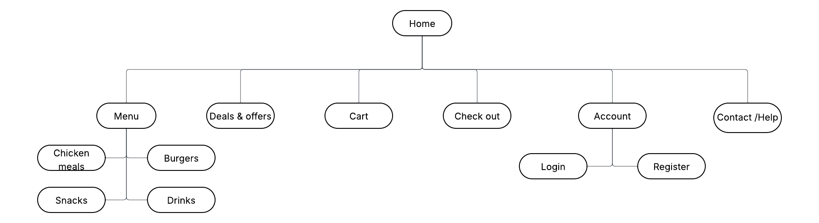
- Navigation Paths
- Home ‘n Menu ‘n Select item ‘n Add to cart checkout ‘n Payment
- Home ‘n Deals ‘n Select offers ‘n Add to Cart ‘n checkout
- Home ‘n Account ‘n Login ‘n Place order
- Home ‘n cart ‘n Edit order ‘n checkout

- Storyboard Flowchart

